What is SQLite Dump?
A SQLite Dump is the process of exporting the contents of a SQLite database into a text file containing SQL commands. These SQL commands can later be executed to recreate the database, including its structure and data.

A dump file usually contains:
- CREATE TABLE statements
- CREATE INDEX statements
- INSERT INTO statements
- Triggers (if any)
- Views (if any)
SQLite dump files are generally stored with a .sql extension.

Example:
CREATE TABLE Student(
id INTEGER PRIMARY KEY,
name TEXT,
city TEXT
);

INSERT INTO Student VALUES(1,'Rahul','Surat');
INSERT INTO Student VALUES(2,'Neha','Valsad');

Why do we use SQLite Dump?
SQLite Dump is used for:
- Database Backup
- Database Migration
- Data Recovery
- Sharing Database
- Copying Database Structure
- Creating Sample Databases
- Version Control

Advantages
- Human readable
- Easy backup
- Portable
- Can recreate complete database
- Useful for debugging

SQLite Dump Command
SQLite DUMP
The DUMP command in SQLite is used to Backup or Restore any Database, Table, or Schema. But unlike other Functions of SQLite, the DUMP command is used with e "." (Dot) in front of it. These types of SQLite commands are called Dot-Commands. DUMP commands are used to dump Tables, Databases, Schemas, etc to some other file.
How To Use The SQLite Dump Command
The DUMP command is a Dot-Command used in SQLite3, so it is used with a preceding dot.
Syntax:
.dump <table_name> [OPTIONAL]

Explanation:
The <table_name> after the DUMP command must be provided whenever the user want to just dump a single Table and not the entire Database. In other times, it is not necessary to provide anything after the DUMP command.
If we use the .dump command singularly, then all the SQL statements used will be given as output in the same Command Line, it will not be saved anywhere.
To understand the DUMP command in more depth we need a 2 table on which we will perform queries. Here we have table called Employees and Students.
After inserting data into the table, Our table looks:
Employees Table:
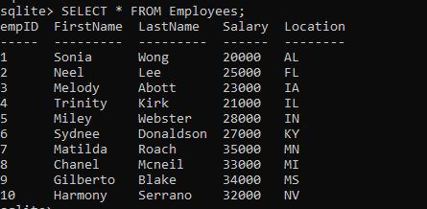
Students Table:
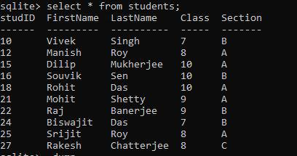
Now, if we use the dump command now, without mentioning anything else, then all the SQL statements used to create and populate the table will be given as output.
.dump
Output:
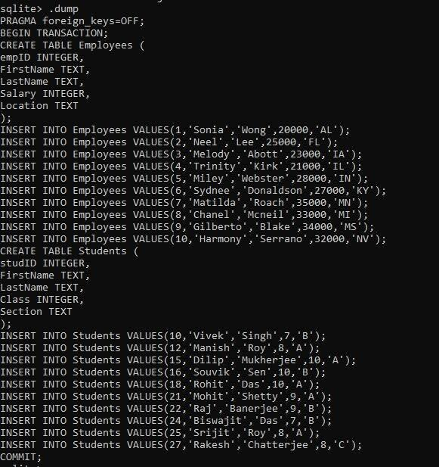
Explanation: Using the DUMP dot command, it alone returns all the commands used till now to create and populate the table. It returns the output as a transaction, that's why the BEGIN TRANSACTION and COMMIT is being displayed here which is not required while writing the actual commands.
Dump Entire Database Into file using DUMP Command
Here, we will dump an entire database into a file using the DUMP command. To do that firstly, we need to provide the name and extension of the file in which we want to store the result with the .output command. Then we have to use the .dump command.
Query:
.output <Location of File with Filename.Extension>
.dump
Now, we will store all those commands i.e the output of the .dump command to a text file named Employee_Details.txt. Write the below commands one by one, just replace the file's location with the user's one:
Query:
.output C:\Users\user\Downloads\SQLite\Database_Details.txt
.dump
Output:
Explanation: Here we are providing the entire path and the name of the file in which we want to store the results of the dump dot command. Even though the file and the SQLite resides in the same folder, it is recommended to provide the entire path of the file to stay on the safer side. After that we will just run the DUMP command and everything will be stored in the file we mentioned in the previous step alongwith the .output command.
Content saved in the Output File:
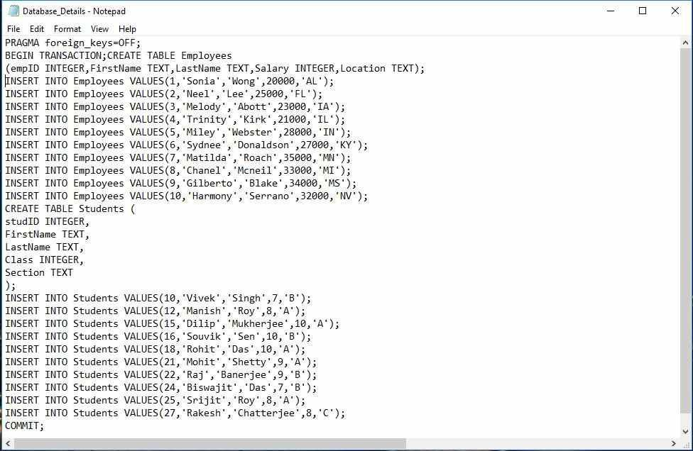
Dump Specific Table Using Dump Command
Sometimes, we might need to dump only a specific table into another file, not the entire database. For that, the syntax will change a bit. We need to provide the output filename as last time, but with the dump command, we need to provide the name of the specific table, which we want to dump.
Syntax:
.output <Location of File with Filename.Extension>
.dump <Table_Name>
Query:
Here, we will dump just the Employees table into a file named Employee_Table.txt
.output C:\Users\user\Downloads\SQLite\Employee_Table.txt
.dump Employees
Explanation: Here, just like the last time we are using the output dot-command and providing the entire path of the file in which we want to store the results / commands. But the difference is, here we just want to store the commands used to create and populate a certain table of the database, not the entire database. This is why we need to provide the name of the Table after the DUMP command to signify that we want to store the commands related to that table only.
Content of the Employee_Table Text File After Dumping:
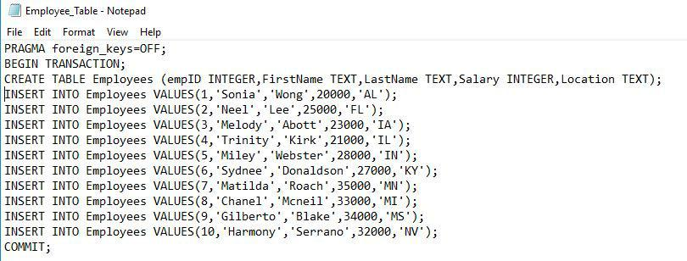
Explanation: As we can see, only the details of the Employees table has been saved / dumped. Not the entire Database.

Dump Tables Structure Only Using Schema Command
There is a variation of this command, using it alone will store the schema of all the tables present in database, but if we pass the name of a specific table then it will only store that.
Now, we will not dump the contents of any table, but we will dump the structures of the table using the .schema command. .schema is a dot-command same as of the .dump command, it is used to dump only the structure or schema of the tables, just like the .dump command, it is used after the .output command.
Syntax:
.output <Location of File with Filename.Extension>
.schema
Query:
We will store the structure in a file called Table_Structure.txt. Write the below command to Dump the tables structure using the schema command:
.output C:\Users\user\Downloads\SQLite\Table_Structure.txt
.schema
Explanation: Just like everytime, we will first provide the entire path of the file in which we want to store the schema of the tables with the output dot command. Then we will call the schema dot command alone, and this will store every tables' structure into that file.
Contents of the Table_Structure.txt:
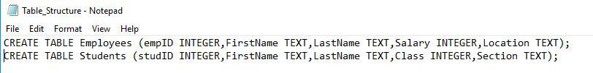
Explanation: This stores the structures of all the tables present in the database.
If we want to store the structure of a specific Table of the database, then we need to provide the table name after the .schema command.
Syntax:
.output <Location of File with Filename.Extension>
.schema <Table_Name>
Query:
Saving the Schema of the Students table:
.output C:\Users\user\Downloads\SQLite\Student_Structure.txt
.schema Students
Explanation: Here after providing the path of the file in which we want to store the output, we are using the schema command alongside the table called Students. This is to signify that we want to store the schema of the only Students table, not every table present in database.
Contents of the Student_Structure.txt file:
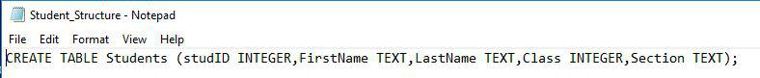

Dump Data of One or More Tables Into File
To dump the data of one or more tables into a file, we first need to change the mode into insert, this will ensure that whenever we use the select statement in command line, in the file all the insert statements will be dumped. We also need to provide a filename with an extension with the .output dot-command to point out in which file the results will be stored.
Syntax:
.mode insert
.output <filename.extension>
Query:
Now if we run the select statement to fetch the values of Employees table only, all the insert statement used for the Employees table, will be dumped and saved in the file mentioned.
.mode insert
.output mydata.txt
Query:
Now using the Select statement:
SELECT * FROM Employees;
Content of the mydata.txt file:
INSERT INTO "table"(empID, FirstName, LastName, Salary, Location) VALUES(1, 'Sonia', 'Wong',20000,'AL');
INSERT INTO "table"(empID, FirstName, LastName, Salary, Location) VALUES(2, 'Neel', 'Lee', 25000, 'FL');
INSERT INTO "table"(empID, FirstName, LastName, Salary, Location) VALUES(3, 'Melody','Abott', 23000, 'IA');
INSERT INTO "table"(empID, FirstName, LastName, Salary, Location) VALUES(4, 'Trinity', 'Kirk', 21000, 'IL');
INSERT INTO "table"(empID, FirstName, LastName, Salary, Location) VALUES(5, 'Miley', 'Webster',28000, 'IN');
INSERT INTO "table"(empID, FirstName, LastName, Salary, Location) VALUES(6, 'Sydnee', 'Donaldson', 27000, 'KY');
INSERT INTO "table"(empID, FirstName, LastName, Salary, Location) VALUES(7, 'Matilda', 'Roach', 35000, 'MN');
INSERT INTO "table"(empID, FirstName, LastName, Salary, Location) VALUES(8, 'Chanel', 'Mcneil', 33000, 'MI');
INSERT INTO "table"(empID, FirstName, LastName, Salary, Location) VALUES(9, 'Gilberto', 'Blake', 34000, 'MS');
INSERT INTO "table"(empID, FirstName, LastName, Salary, Location) VALUES(10, 'Harmony', 'Serrano', 32000, 'NV');
If we now run the select statement again but for the Students Table, the content will be updated as below:
Output:
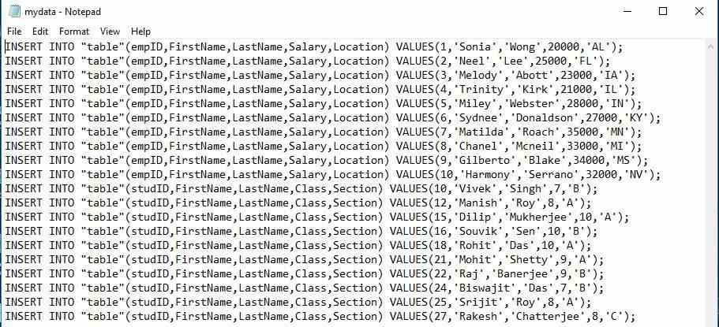

If you use sqlite3, these commands are useful:
Operation | SQLite Command
Dump entire database | .dump
Dump one table | .dump Student
Backup database | .backup college_backup.db
Show tables | .tables
Show schema | .schema
Show schema of Student | .schema Student
List databases | .databases
Open database | .open college.db
Save database | .save newcollege.db
Exit SQLite | .quit

Practical 1: Create Database and Insert Records
import sqlite3
# Connect to database
conn = sqlite3.connect("college.db")
cursor = conn.cursor()
# Create table
cursor.execute("""
CREATE TABLE IF NOT EXISTS Student(
RollNo INTEGER PRIMARY KEY,
Name TEXT,
Course TEXT,
Marks INTEGER
)
""")

# Insert Records
students = [
(101, "Rahul", "BCA", 85),
(102, "Amit", "BCA", 78),
(103, "Priya", "BSc", 91),
(104, "Neha", "BCA", 88)
]

cursor.executemany("INSERT OR IGNORE INTO Student VALUES(?,?,?,?)", students)

conn.commit()
print("Database Created Successfully.")
conn.close()

Practical 2: Backup Complete Database (.dump equivalent)
import sqlite3
conn = sqlite3.connect("college.db")
# Create Backup File
with open("college_backup.sql", "w") as file:
for line in conn.iterdump():
file.write("%s\n" % line)

print("Database Backup Created Successfully.")
conn.close()

Output File

BEGIN TRANSACTION;
CREATE TABLE Student(
RollNo INTEGER PRIMARY KEY,
Name TEXT,
Course TEXT,
Marks INTEGER
);

INSERT INTO Student VALUES(101,'Rahul','BCA',85);
INSERT INTO Student VALUES(102,'Amit','BCA',78);
INSERT INTO Student VALUES(103,'Priya','BSc',91);
INSERT INTO Student VALUES(104,'Neha','BCA',88);

COMMIT;
This file is exactly similar to SQLite's .dump output.

Practical 3: Backup Only Database Structure

import sqlite3
conn = sqlite3.connect("college.db")
cursor = conn.cursor()
cursor.execute("""
SELECT sql
FROM sqlite_master
WHERE type='table'
""")

with open("structure.sql", "w") as file:
for row in cursor.fetchall():
file.write(row[0] + ";\n\n")

print("Database Structure Exported.")
conn.close()

Output
CREATE TABLE Student(
RollNo INTEGER PRIMARY KEY,
Name TEXT,
Course TEXT,
Marks INTEGER
);

Practical 4: Backup Only Data

import sqlite3
conn = sqlite3.connect("college.db")
cursor = conn.cursor()
cursor.execute("SELECT * FROM Student")
rows = cursor.fetchall()
with open("data_backup.sql","w") as file:
for row in rows:
sql = f"INSERT INTO Student VALUES({row[0]},'{row[1]}','{row[2]}',{row[3]});"
file.write(sql+"\n")
print("Data Backup Completed.")
conn.close()

Output
INSERT INTO Student VALUES(101,'Rahul','BCA',85);
INSERT INTO Student VALUES(102,'Amit','BCA',78);
INSERT INTO Student VALUES(103,'Priya','BSc',91);
INSERT INTO Student VALUES(104,'Neha','BCA',88);

Practical 5: Restore Database from Backup

import sqlite3
conn = sqlite3.connect("restore.db")
cursor = conn.cursor()
with open("college_backup.sql","r") as file:
sql_script = file.read()
cursor.executescript(sql_script)
conn.commit()
print("Database Restored Successfully.")
conn.close()

Practical 6: Export Complete Database to Another File

import sqlite3
source = sqlite3.connect("college.db")
destination = sqlite3.connect("college_copy.db")
source.backup(destination)
print("Database Copied Successfully.")
source.close()
destination.close()

Practical 7: Display All Tables
import sqlite3
conn = sqlite3.connect("college.db")
cursor = conn.cursor()
cursor.execute("""
SELECT name
FROM sqlite_master
WHERE type='table'
""")

tables = cursor.fetchall()
print("Tables in Database")
for table in tables:
print(table[0])
conn.close()

Output
Tables in Database
Student

Practical 8: Display Database Schema

import sqlite3
conn = sqlite3.connect("college.db")
cursor = conn.cursor()
cursor.execute("""
SELECT sql
FROM sqlite_master
WHERE type='table'
""")
for row in cursor.fetchall():
print(row[0])
conn.close()

Output
CREATE TABLE Student(
RollNo INTEGER PRIMARY KEY,
Name TEXT,
Course TEXT,
Marks INTEGER
)

Practical 9: Count Total Records
import sqlite3
conn = sqlite3.connect("college.db")
cursor = conn.cursor()
cursor.execute("SELECT COUNT(*) FROM Student")
count = cursor.fetchone()[0]
print("Total Records =", count)
conn.close()

Output
Total Records = 4

Practical 10: Complete Database Maintenance Utility

import sqlite3
conn = sqlite3.connect("college.db")
print("Connected Successfully")
# Backup
with open("backup.sql","w") as file:
for line in conn.iterdump():
file.write("%s\n" % line)
print("Backup Created")
# Show Tables
cursor = conn.cursor()
cursor.execute("SELECT name FROM sqlite_master WHERE type='table'")
print("\nTables")
for table in cursor.fetchall():
print(table[0])
# Record Count
cursor.execute("SELECT COUNT(*) FROM Student")

print("\nTotal Students :", cursor.fetchone()[0])
conn.close()
print("\nMaintenance Completed")

Output
Connected Successfully
Backup Created
Tables
Student
Total Students : 4
Maintenance Completed

Assignment Questions
- Write a Python program to create a library.db database and dump only the Book table (structure and data) into a SQL file.
- Write a Python program to export only the structure of the Employee table without its records.
- Write a Python program using iterdump() to create a complete backup of a SQLite database and restore it into a new database.
- Write a Python program to export the data of Student, Course, and Faculty tables into a single SQL file containing only INSERT statements.

